Richards, Biddle Enter Football Hall of Fame
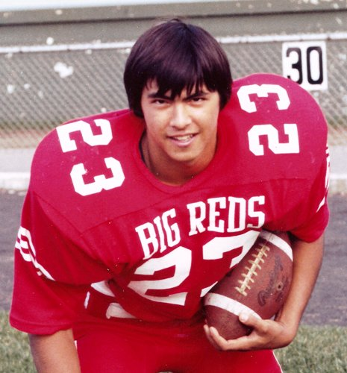
The only three time 1,000 yard rusher in the history of Parkersburg High School and one of its fiercest defenders who went on to become a legendary college coach highlight the first two inductees for the Class of 2011 of the Big Red Football Hall of Fame.
John Richards, who played on two state championship teams while displaying uncanny durability as a running back, and all-state lineman Dick Biddle will kick off the newest Hall of Fame class when they are inducted into the shrine on Friday night (Aug. 26) prior to the PHS season opener against Ohio River rival Brooke.
From the moment he stepped onto the Big Red gridiron as a gangly sophomore, Richards was the PHS tailback. His consistency was amazing. He ran for 1,101 yards and scored seven touchdowns as a sophomore on a state championship team. As a junior he ran for 1,121 yards with 10 touchdowns on a team which lost in the first round of the playoffs on a last-second touchdown to Beckley. As a senior he piled up 1,733 yards and scored 16 touchdowns on another state championship team. He started 36 games as a Big Red and his team won 30 of those contests.
Richards was a first team all-state selection as a senior and made the Carnation Prep All-American and All-Academic team. He finished as the all-time leading rusher in PHS history with 3,955 yards and currently stands second to current WVU fullback Matt Lindamood. After scoring 246 points during his career, he received a football scholarship and played one year at West Virginia University.
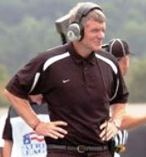
Biddle was the outstanding lineman and defender for coach Russ Parsons in 1963 and 1964 when the Big Reds posted back-to-back 8-2 records. He was named first team all-state as a senior and was also a three year letter winner in wrestling.
As a 17-year-old the 6-foot, 200 pound Biddle was called by Parsons the best tackle he had coached in over 20 years. As a senior the Big Reds held nine opponents to one touchdown or less, shutting out six of them. Only a 7-6 loss to Huntington and a 28-14 defeat at Beckley kept them from an undefeated season.
A fierce competitor known for his snarling face on the football field, Biddle went on to even bigger and better things, becoming a two-time All-Atlantic Coast Conference linebacker and third team All-American at Duke and then going into the coaching ranks, where he would become the all-time winningest coach in Colgate history. He was named the head coach there in 1995 and became only the third coach in NCAA history to take over a winless team and produce a winning record in his first year. In 2003 he was named National Coach of the Year after leading his team to a 15-1 record and a berth in the national championship game. He is currently in his 16th season at the helm of the Raiders and has a record of 120 wins and only 55 losses. He is returning to his home town for the first time in 30 years.

